**Mild to Moderate evaluation:**

Sample_Id:**AHFCMV(cat)**

Link:<https://release.animalbiome.com/pet/assessment/report/summary/91fd015d-0b0d-4947-b962-7cbb861c2c4a>

Mild to Moderate:

Cats and dogs:

Any Two

(High Yellow Flag Megamonas OR  **(Passed)**

High Yellow Flag Sutterella OR (failed)

High Yellow Flag Collinsella OR (failed)

Low Yellow Flag Bacteroides OR (failed)

Low Yellow Flag Blautia **(Passed)**

)

OR Cats: 8-10 Yellow Flags(**Passed**)9

OR 5-8 Red Flags;(**Passed**)7

OR dietary recommendation of increase fiber (**Passed**)

or protein or decrease carbs(**Failed**)

Or Escherichia High(**failed**)

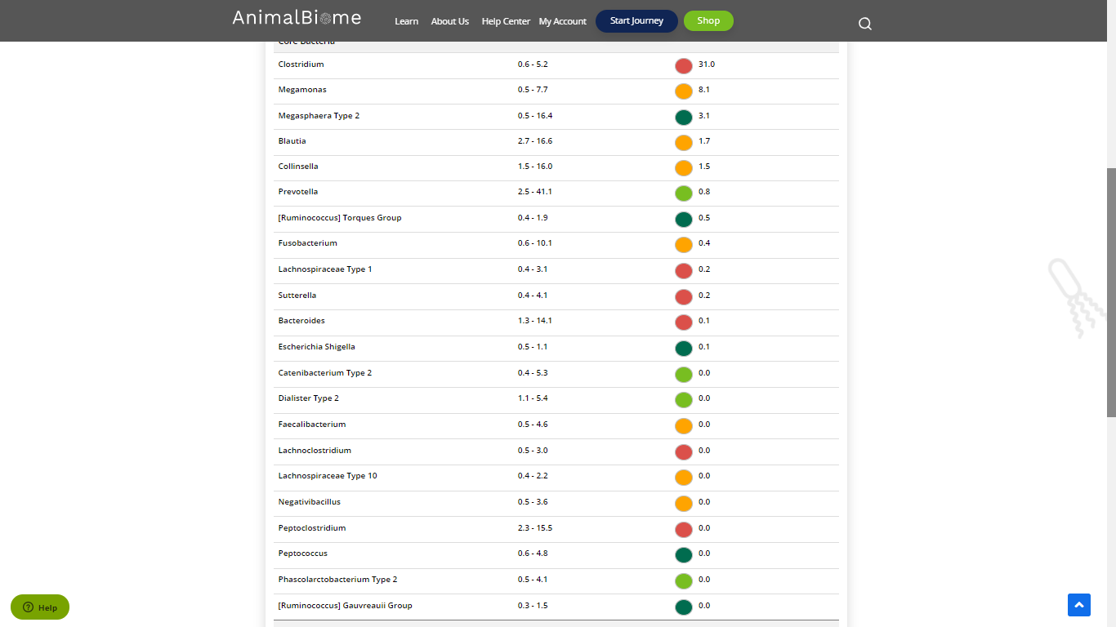

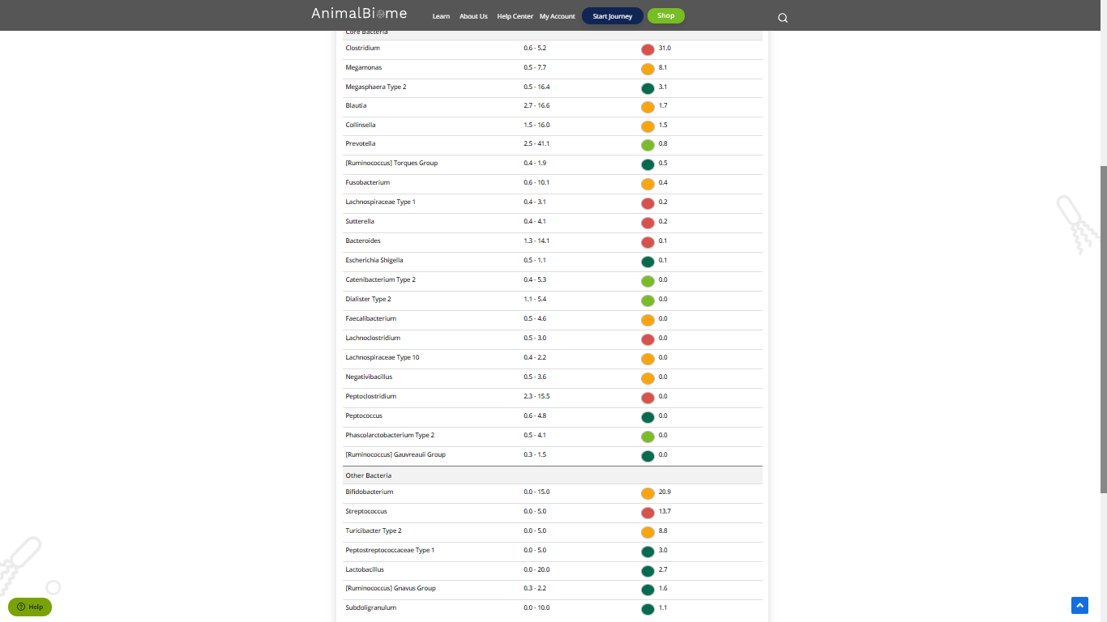

The result : **True True True True**

Mild to moderate evaluation results:Pass

Expected result : Mild to moderate

Achieved result : **passed.**

